**PPC Campaign Report**

Competitor Keywords Analysis:

* Keyword: Creative Forts
  + Price Range: $0.22 - $0.43
  + Difficulty: High
  + Volume: 100 – 1K
* Keyword: Indoor Fort Building Kit
  + Price Range: $0.15 - $1.30
  + Difficulty: High
  + Volume: 100 – 1K
* Keyword: National Geographic Toys
  + Price Range: $0.18 - $1.75
  + Difficulty: High
  + Volume: 1K – 10K
* Keyword: Building Toys
  + Price Range: $0.95 - $2.00
  + Difficulty: High
  + Volume: 1K – 10K

**Campaign Strategy Recommendations:**

* **Keyword Selection:**
  + Focus on keywords with lower competition and higher search volume to maximize visibility and reach.
  + Consider targeting long-tail keywords that are more specific to the product to capture highly relevant traffic.
* **Bid Strategy:**
  + Adjust bids based on the competitiveness of each keyword and its potential for driving conversions.
  + Allocate more budget towards keywords with higher conversion rates and lower acquisition costs.
* **Ad Copy Optimization:**
  + Craft compelling ad copy that highlights the unique features and benefits of the product.
  + Use ad extensions to provide additional information and entice users to click on the ad.
* **Match Types:**
  + Experiment with different match types (exact match, phrase match, broad match modified) to find the optimal balance between reach and relevance.
  + Monitor keyword performance closely and adjust match types accordingly.
* **Continuous Monitoring and Optimization:**
  + Regularly monitor campaign performance metrics such as click-through rate, conversion rate, and return on investment.
  + Use A/B testing to test different ad creatives, landing pages, and targeting strategies to identify the most effective approach.

**Conclusion**:

Based on the analysis of competitor keywords and campaign strategy recommendations, we can optimize our PPC campaigns to improve visibility, drive qualified traffic, and increase conversions for the "100 Pieces Fort Building Kit Plus 5 Light Set for Kids 4-8" product.

**Listing Optimization Report**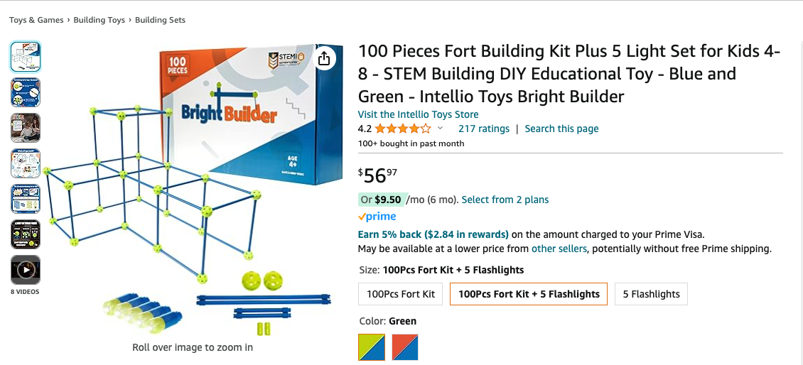

* **Keyword Placement:**
  + Ensure that relevant keywords are placed towards the beginning of the title to improve search visibility. Include keywords related to the product type, key features, target age group, and brand name.
    - **Example**: "STEM Building DIY Educational Toy - 100 Pieces Fort Building Kit Plus 5 Light Set for Kids 4-8 - Blue and Green - Intellio Toys Bright Builder"
* **Key Features and Benefits:**
  + Highlight the main features and benefits of the product in the title to attract potential buyers' attention and convey value.
    - Example: "100 Pieces Fort Building Kit Plus 5 Light Set for Kids 4-8 - STEM Educational Toy - Durable & Sturdy - Indoor/Outdoor Play"
* **Brand Name:**
  + Include the brand name towards the end of the title to establish brand recognition and trust with customers.
    - Example: "100 Pieces Fort Building Kit Plus 5 Light Set for Kids 4-8 - STEM Educational Toy - Intellio Toys Bright Builder"
* **Conciseness and Clarity:**
  + Keep the title concise and easy to read, avoiding unnecessary words or punctuation.
    - Example: "100 Pieces Fort Building Kit Plus 5 Light Set - STEM Educational Toy for Kids 4-8 - Intellio Toys Bright Builder"
* **Capitalization and Formatting:**
  + Use title case capitalization for better readability and professionalism. Avoid excessive capitalization or special characters.
    - Example: "100 Pieces Fort Building Kit Plus 5 Light Set - STEM Educational Toy for Kids 4-8 - Intellio Toys Bright Builder"

### **Product Description:**

"Introducing Bright Builder—the ultimate fort-building kit designed to ignite children's creativity and imagination. Our 100 Piece Fort Kit is more than just a toy—it's a gateway to endless adventures and learning opportunities.

Crafted with high-quality materials and featuring a *patented* locking mechanism, Bright Builder ensures durable and sturdy construction that can withstand even the most enthusiastic building sessions. Watch as your children explore their creativity and develop essential motor and cognitive skills while confidently building their forts.

Certified by STEM, our fort-building kit is designed to foster learning through play, encouraging problem-solving, spatial awareness, and imaginative thinking. Whether indoors or outdoors, kids can immerse themselves in the world of construction and design, creating their unique structures and environments.

And with our optional add-on light set, the fun doesn't have to end when the sun goes down. Illuminate your creations and extend playtime into the evening, creating magical memories that will last a lifetime.

At Intellio Toys, we believe in the power of play to inspire, educate, and empower children. Join us in building a brighter future with Bright Builder—the ultimate fort-building adventure awaits!"

By refining the bullet points and product description in this way, we can effectively highlight the key features, benefits, and unique selling points of the "100 Piece Fort Kit," attracting potential customers and encouraging conversions.

### **Proposal: Predictive Model for Listing Optimization Strategies**

It's possible to create a predictive model that helps identify effective listing optimization strategies. The model can analyze historical data on listing performance, including factors such as keyword usage, title optimization, image quality, and review ratings, to identify patterns and trends associated with successful listings. By training the model on a dataset of past listing optimization efforts and their outcomes, it can predict which strategies are likely to be most effective for a given product or category. Machine learning algorithms such as regression, decision trees, or neural networks can be used for this purpose. Additionally, a predictive model can assist in identifying effective optimization strategies based on historical data and performance metrics.